Oracle Database Administration Services

KE_ORACLE_Tablespace size issue

Submitted to



By



CIS, Wipro Limited

Document Details

Project Name | Innogy SE
Account | CIS
IT Component/Application Title | KE_ORACLE_Tablespace size issue
Current Version | 1.5
List of Contributors | Kamlesh Sawant , Saurabh Nigam , Abhishek Kansal  Jiten Pansara, Sreya Puthukudy
Customer Contact Information

Version History
(All revisions made to this document must be listed in chronological order. All revisions must be approved. Review and Approval can be done by an internal source or by the customer)
Version | Date of Revision | Description | Author | Reviewed By | Approved By
1.0 | 29-08-2016 | Intial Draft | Kamlesh Sawant | Saurabh Nigam | Mahesh Keshatwar
1.1 | 04-09-2016 | Document Completed | Kamlesh Sawant | Saurabh Nigam | Mahesh Keshatwar
1.2 | 21-10-2016 | Updated document to standard format | Kamlesh Sawant | Saurabh Nigam | Mahesh Keshatwar
1.3 | 17-05-2017 | Wipro and Innogy Logo changed | Kamlesh Sawant | Jiten Pansara | Mahesh Keshatwar
1.4 | 14-11-2017 | Updated document to Wipro Standard format with header and footer | Abhishek Kansal | Jiten Pansara | Yogesh Desai
1.5 | 16-12-2018 | Updated the content | Sreya Puthukudy | Jiten Pansara | Santosh Badiger

Error Description:
ORA-01652: unable to extend <tablespace_name>

Impact:
Unable to insert data in particular tablespace.
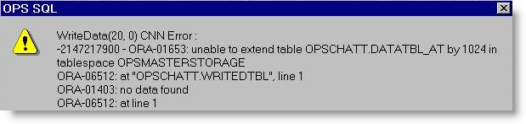

Root cause:
During addition of data if the space is not available then it will throw this error.
Workaround:
Need to increase size of tablespace(add datafiles)
1. Login to the server
2. ps -ef|grep pmon
3. Connect the database
4. Sqlplus "/ as sysdba"
5. select file_name,sum(bytes/1024/1024) from dba_data_files where tablespace_name='<tablespace_name>';
6. alter database datafile '<datafile_path>' resize <particular_size>M;
OR
7. alter tablespace <tablespace_name> add datafile '<datafile_path'> size <particular_size>M;

